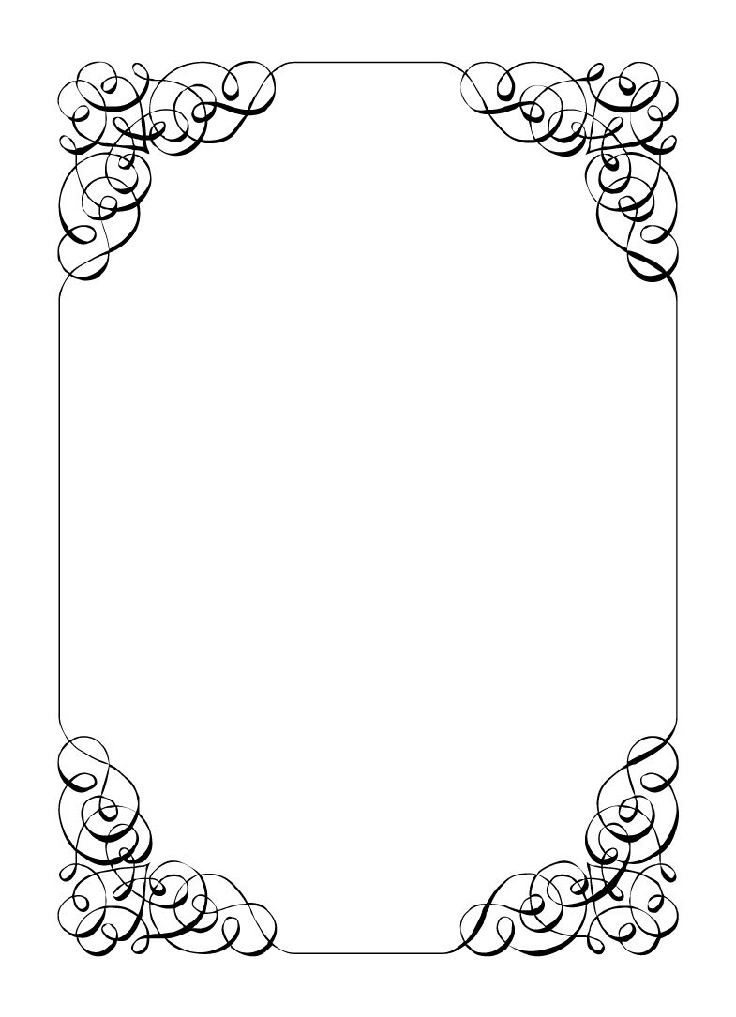

Not here to wed spiders

Dave Torana

*In the small town of Duck Rise, Victoria, Stralya live: BOGANS. Bogans are much like the regular folk, but drunker and louder. Some of them even fall in love. But before they settle down and poop out a mess of kids, they gotta have a wedding! Weddings are the best. Everyone gets proper plastered. Lots of kissing. Lots of drama. Fun times for all. Nothing ever goes wrong at a wedding...*  
*\*\*ominous thunder clack\*\**

Dave Torana

Best Man *Smooth talker, Manipulative, Sexy*

You always worked very hard on your appearance. You wanted people to like you. But even on your off days Chad still liked you and that made things easier. When the wedding came up, you were so happy for him. Everything is looking like sunshine and rainbows.

**Last night:** You were at the Bachelor party. Chad, Wayne, Malibu, Sparkie, and Lucky were there. You kidnapped the Groom and brought him on the greatest pub crawl of all time, finishing at the casino late in the night. You went light on the drinks because you wanted to be sharp for your best friend's wedding the next day. You had to put Sparkie in a taxi at some point, as he was too far gone. After the casino you all went back to a hotel and you and the Groom and you split a room.  
One thing led to another and you both boned down. Hard. (Sex). It was something you had always thought about but didn't think would ever happen. Everyone thinks you got strippers for the night, and you've decided to let everything think that.

**Goals**

* **Replace the bride and marry Chad:** You love that gorgeous son of a gun. You want him all to yourself.
* **Rekindle Malibu's old love:** Malibu seemed real broken up at the bucks about an old flame. Help them.
* **Get Robin fired:** They think they are better than us. Get Chad or someone else to kick them out of the wedding.
* **Act cool and get a photo with everyone:** Make sure everyone thinks you are cool by the end of the wedding. You are a cool guy after all.
* **Find a way to make the dog like you the best:** You love dogs but they don't always love you. Find a way to bribe Lucky to be your friend.

**Other People**

**Chad Marolla**

Last night at the Bachelor party fulfilled a long lasting dream for you. You now know Chad is the one. I'm sure he feels the same way, after all you've never had a problem getting others to love you back when you put your charm on.

**Corolla Castro**

Honestly she is lovely. You can see Chad's eyes light up when they see her. Which is a BIG problem. She must go.

**Gemini Belmont**

Gemini is fiery, which in your world means trouble. She is not your type, and you think keeping a big distance is a solid idea, but you've had to date worse to keep your secrets in the past.

**Mercedes Bennie**

You are pretty sure you've seen her at the local night club (Barrels). How a 12 year old regularly gets in there is beyond you.

**Robin Smith**

Pretty fit for his age, perhaps his harsh exterior is only an act for the job and with a little persuasion could be convinced to have some fun.

**Malibu Singer**

You really connected last night at the bachelor party. Malibu might of got laid but you can tell a broken heart when you see one (after all you've broken so many). Time to be a best-wing-man.

**Lucky the Wonder Dog**

Likes belly rubs, just like you. Is a great wing-man in a pinch.

**Mungo Joint**

Takes a mean photo. You should get Mungo to shoot you some new smoking hot pics for instagram.

**Abilities**

Use these to do things. They have a limited use, so check them off when you use them.

|  |  |
| --- | --- |
| Ability | Sweet Talker |
| Flirt with another character. If you manage this, the player must show you their information. |
| Usages: O O O |

|  |  |
| --- | --- |
| Ability | Other People |
| Offer someone a cigarette/lighter. If you accept it, the player must show you their other people section for the character of your choice. |
| Usages: O O O |

|  |  |
| --- | --- |
| Ability | I never kiss and tell |
| If someone uses an ability on you that forces you to reveal your information or secret, show this ability to them and keep your information or secret hidden instead. |
| Usages: O O O |

**Secret and Information**

Your Secret contains your guilty secret, while your Information contains one or more items of information you know. Both may be affected by abilities. Your lie may need to be filled out later.

While you can show your Secret and Information to whomever you like, you will probably not want to reveal your Secret too often. (Please note that you can’t solve the crime by looking at everyone’s Secret and Information – it’s not that easy!)

|  |  |
| --- | --- |
| Secret | The stripper's never showed up to the hotel last night. |

|  |  |
| --- | --- |
| Information | Vectra recovered from last night better than anyone else. |

**The Organiser’s Word is Law:** The organisers are impartial. If you have a problem or want to do something unusual, see an organiser. The organiser’s power is absolute – and cannot be affected by ability cards!

**Winning and Losing:** You can achieve most of your goals simply by talking to people. The organisers will announce when the game is over. If you haven’t succeeded by that point – you’re too late! Be warned – not everyone here will want you to succeed!

**Doing Stuff:** Ordinary actions are resolved by simply carrying them out. If you want to try something unusual (such as trying to hack the pentagon), see an organiser. The organisers knows everything – and will be able to tell you the outcome of whatever it is that you are trying to do. (For example, you are trying to hack over state lines and you are caught.) Do use your imagination, though! – this is a very flexible game, and you can do all sorts of things beyond what’s listed in these rules.

**Fighting:** If an ability or item lets you hard another player, don’t just dive in! See the organisers first and tell them what you plan to do so they can oversee and give you more detailed rules if it’s necessary.

**Leaving:** You cannot leave, it is rude to leave a wedding and you are in the middle of nowhere!

**Role Cards:** If someone asks you for your role in the wedding ceremony, and you have one, you must show them all your roles.

**Item Cards:** Any items of importance within the game are represented as Item cards – and the only items that can affect the game are those detailed on the cards. If you do not have an Item card, you do not have that item with you.

**Time:** This game is played over three (ish) hours, including time for reading your character etc. There will be breaks throughout the evening! The organisers will tell you when each period starts and finishes.

**Character List**

**Chad Marolla – *Groom***

The soon to be husband. A bit nervous about the wedding, but is letting Corolla take care of the hard stuff.

**Corolla Castro – *Bride***

She knows what kind of wedding she wants, and that's the kind of wedding we are having! NO EXCEPTIONS!

**Gemini Belmont – *Maid of Honour***

She carries herself like she just escaped a warzone. Maybe she did? She's real quiet and might throat punch you if you ask stupid questions.

**Mercedes Bennie – *Flowergirl***

She's 12 but everyone knows better than to treat her like a 12 year old. Punk AF and will burn this all down on a whim.

**Robin Smith – *Priest***

Not from here. Better than everyone else (or at least thinks so).

**Dave Torana – *Best Man***

Childhood friends with the Groom. He was the smooth talking hottie that picked up enough for both of them. But that part of his life is over now.

**Malibu Singer – *Wedding Planner***

For a professional organiser, not very organised. Has just managed to keep everything running so far.

**Sparkie Castro – *Bride's Father***

He's been waiting his whole life for this moment. His baby girl is finally gonna get married and he knows just how to get through the day without crying...

**Vectra Marolla – *Groom's Mother***

The Queen that runs this town. Knows where the bodies are buried, but will never tell. Everyone respects her.

**Wayne Marolla – *Drunk Uncle***

He's maybe had a few too many. Started stumbling around and saying weird things. Every wedding has one.

**Lucky the Wonder Dog – *Dog***

A good dog. *bark* *bark* "What's that Lucky? You want pats?"

**Mungo Joint – *Photographer***

Seems like they are creeping on everyone, but they were hired to take wedding photos so it's probably fine.